**Heroku-STEPS**

1. Choose your use-case

2. Get your dataset prepared and build your model and choose the best model

3. Create a web App using Flask

4. Commit your code to Github

5. Create your account on Heroku

6. Link your Heroku account to your Github account 8. Deploy and test your App

Step 1 – Install Flask Cors through Jupyter Notebook

pip install flask_cors

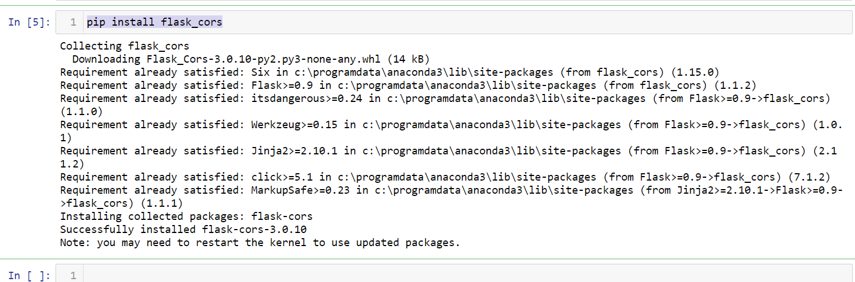

Step 2: Create a folder and keep the files as specified

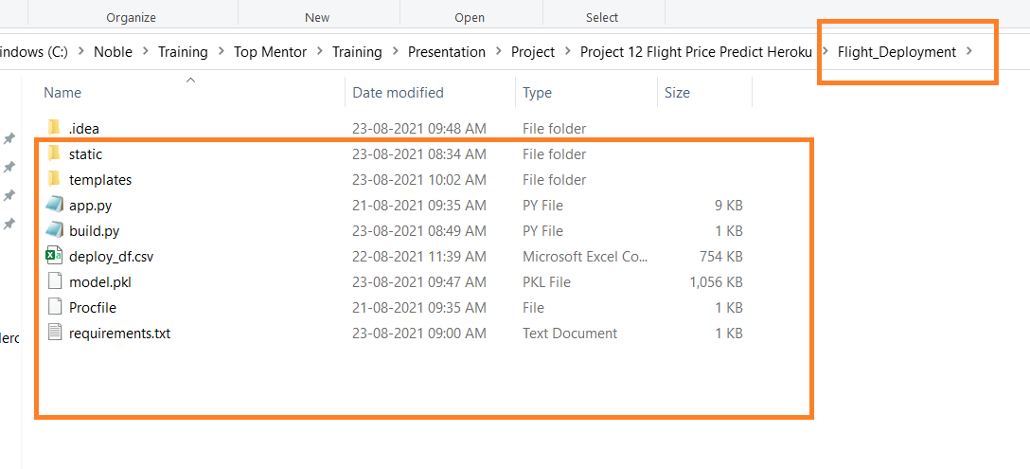

Step3 : Open Pycham

File -> Open

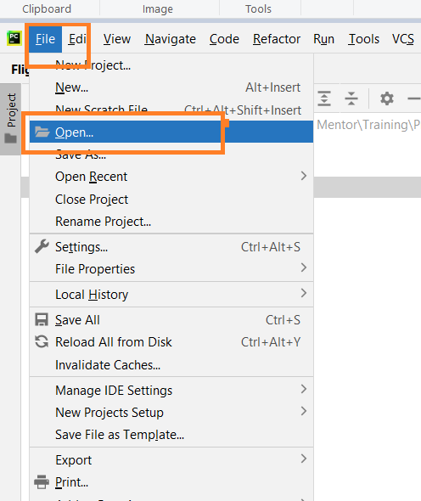

Select the Folder which you created

Click -> OK

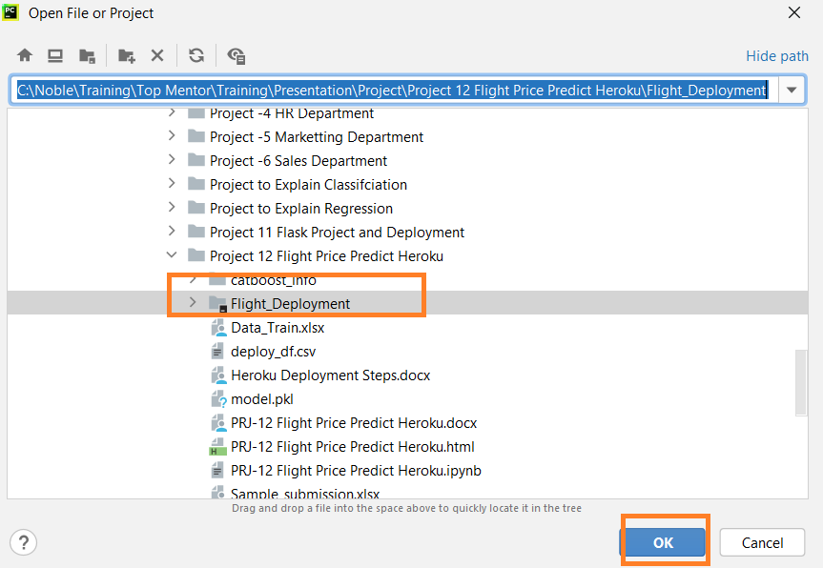

Step4 : Right Click Build.py then Run , This create the model then generate a new pickle file in the same folder

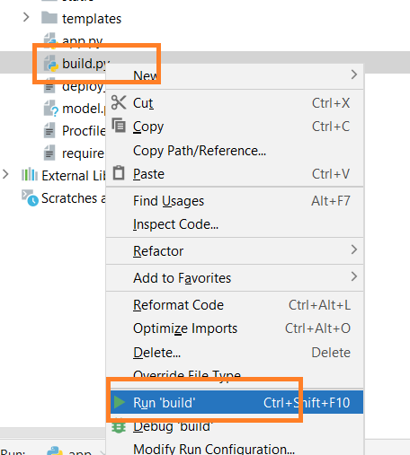

Pickle File

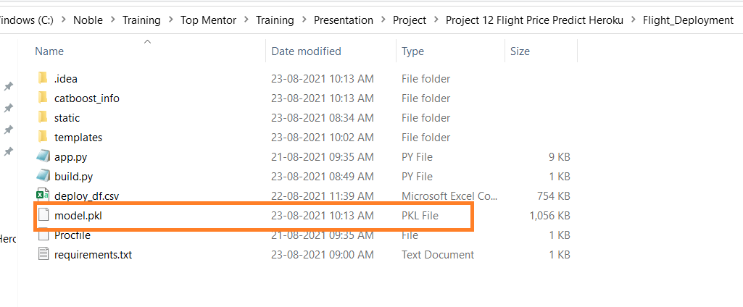

Step5: Right click and Run app.py

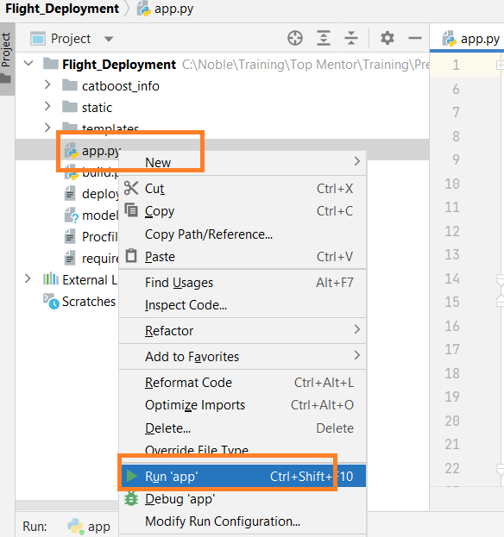

Step6: Copy this URL and open in the Browser

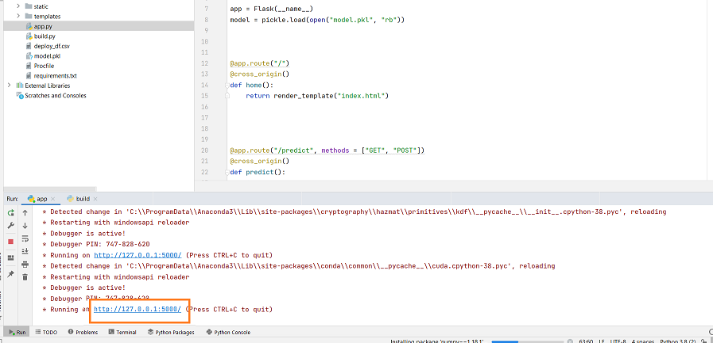

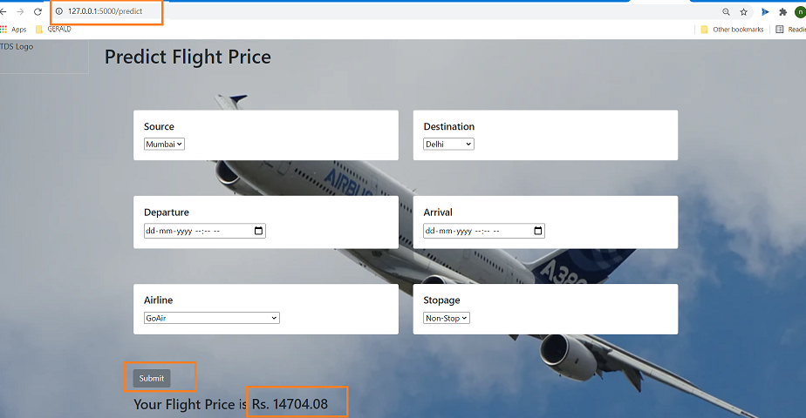

Step7: Sign into Git Hub

<https://github.com/>

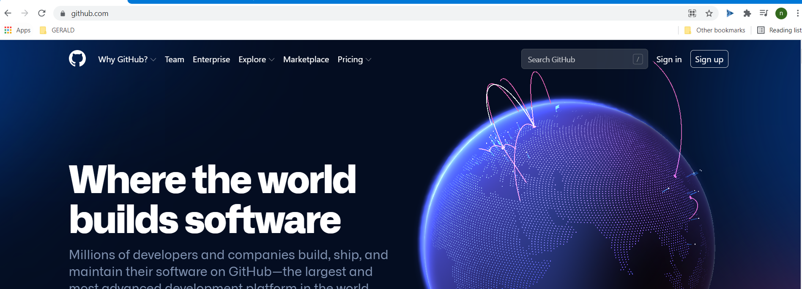

Click on the + Symbol and create a new repository

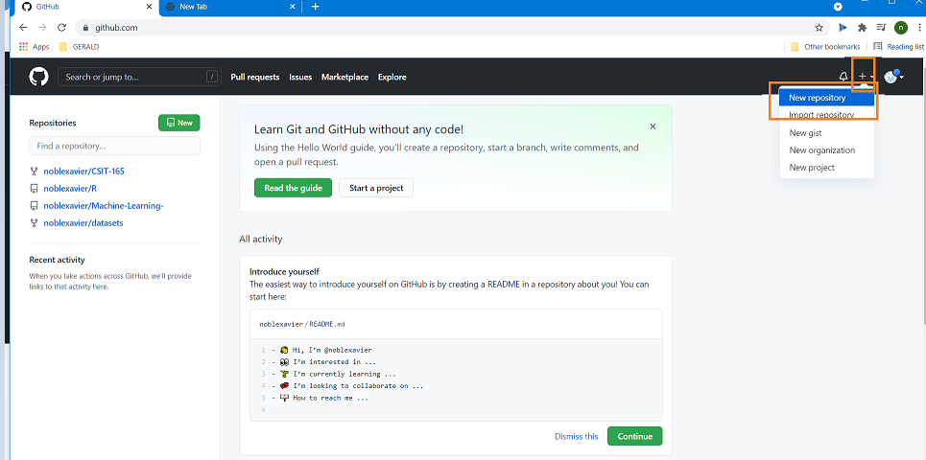

Repository Name: flightdeployment

Then Create a repository

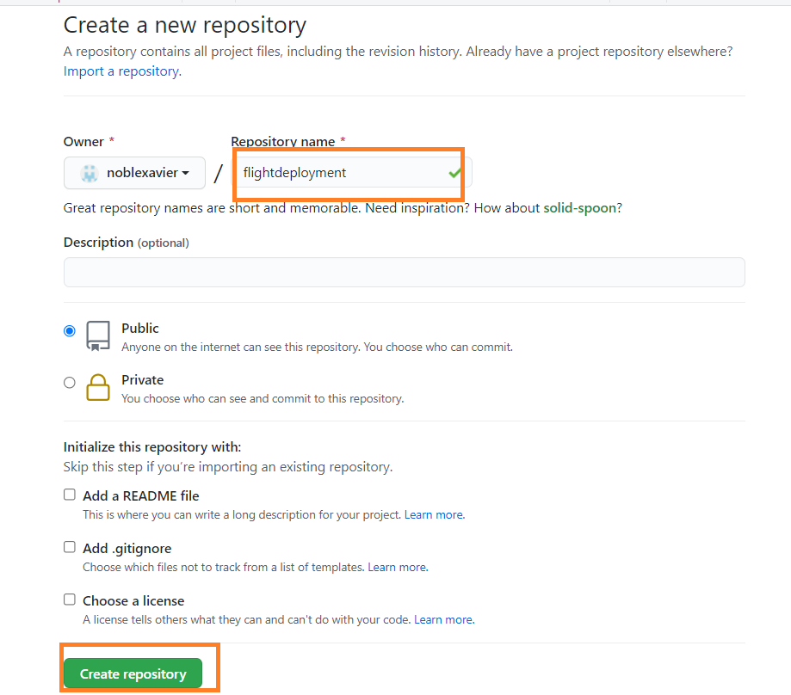

Click Code - > Uploading an Existing File

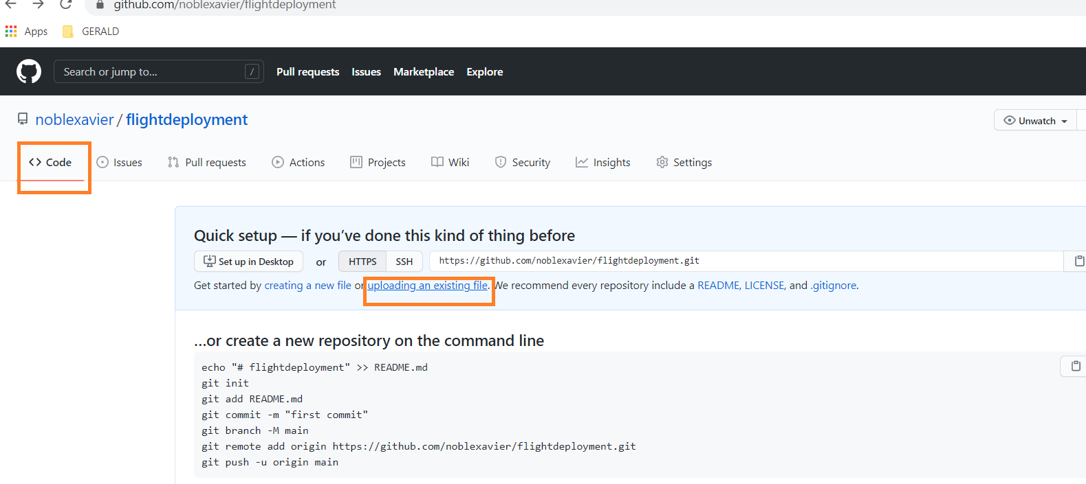

Select Choose your File

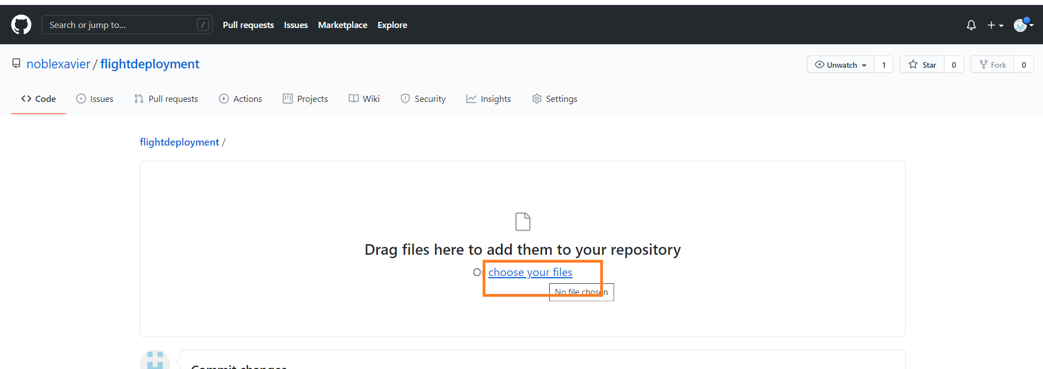

Select CTRL +A ( Select all Files) then Open

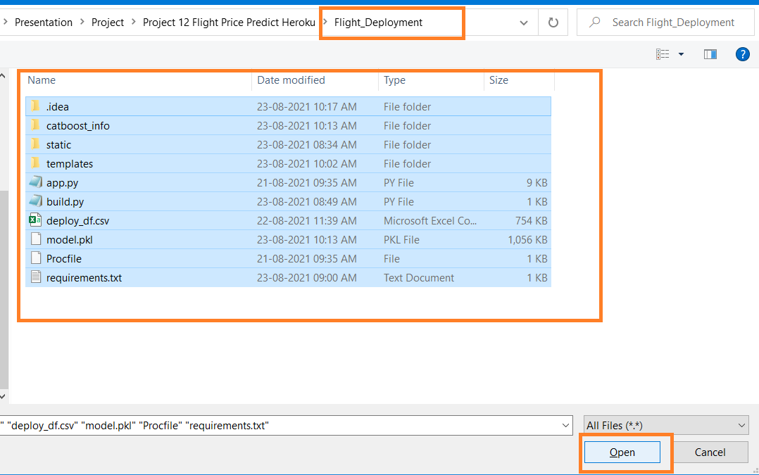

If folders are not getting copied then Drag and Drop the folders ,

Then click on Commit Changes

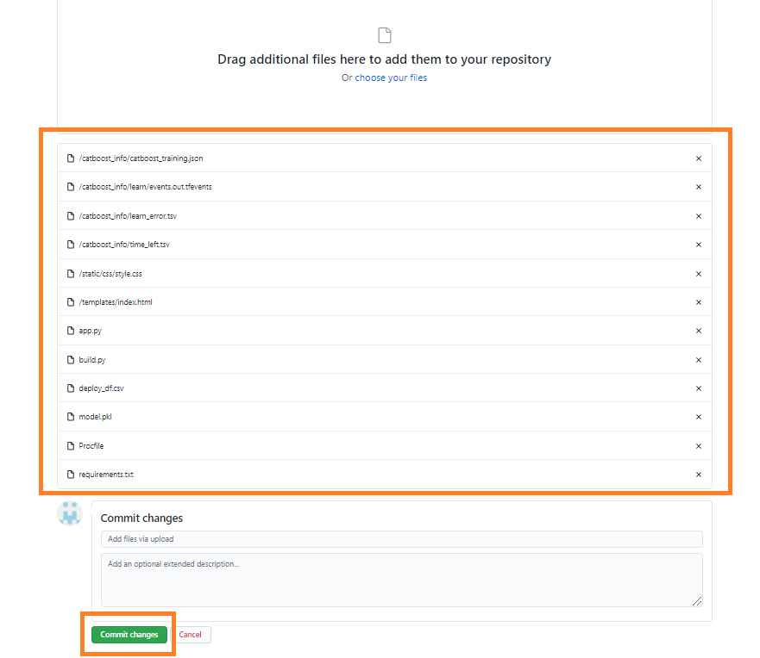

Create an Account in Heroku

<https://signup.heroku.com/>



Once the account created, activate the account by clicking the URL in the specified email ID

Enter New password and Login

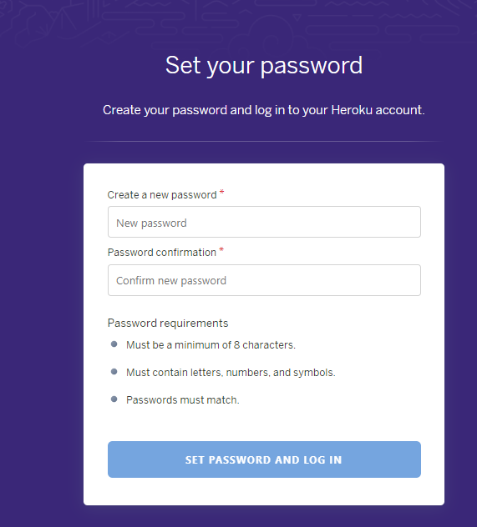



After Login

Go to (Click) New

Click -> Create a new App

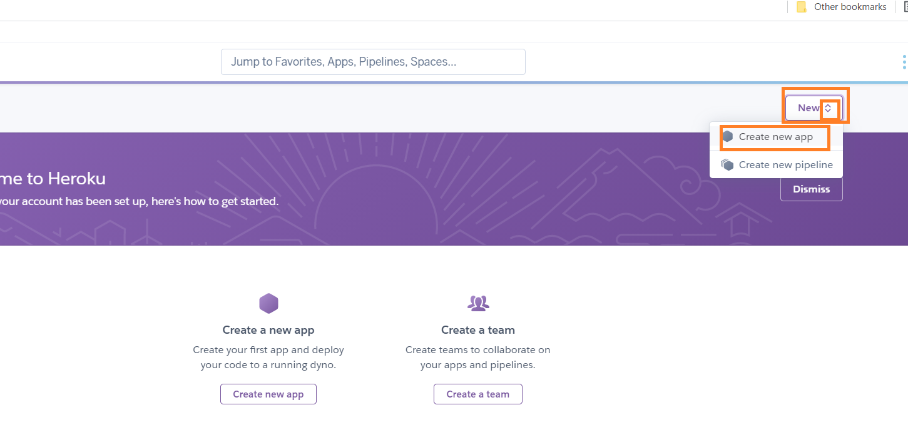

Enter App Name <<appname>>

Click - > Create App

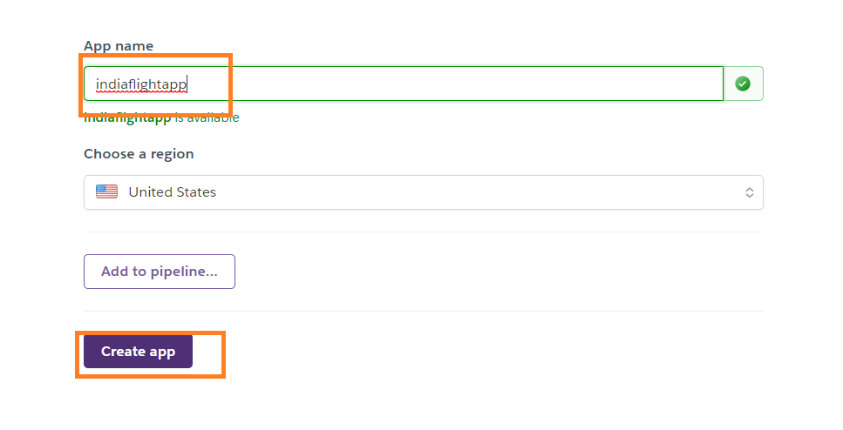

Under Deployment Method

Click GitHub Connect to GitHub

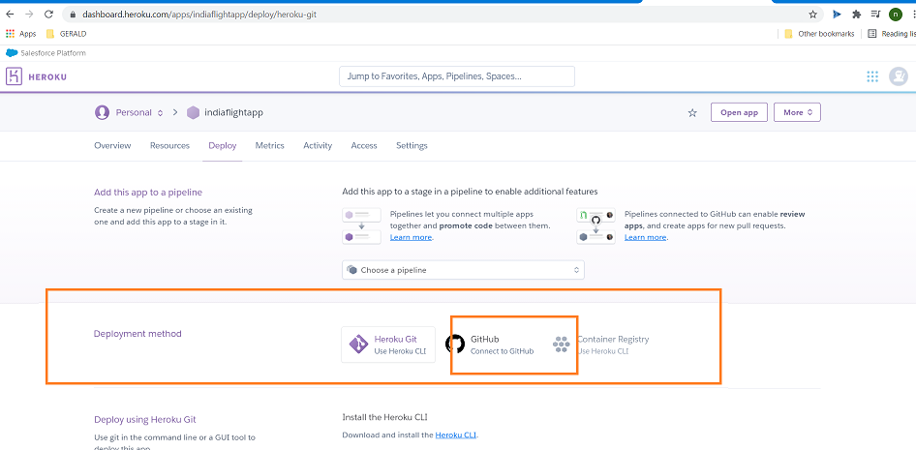

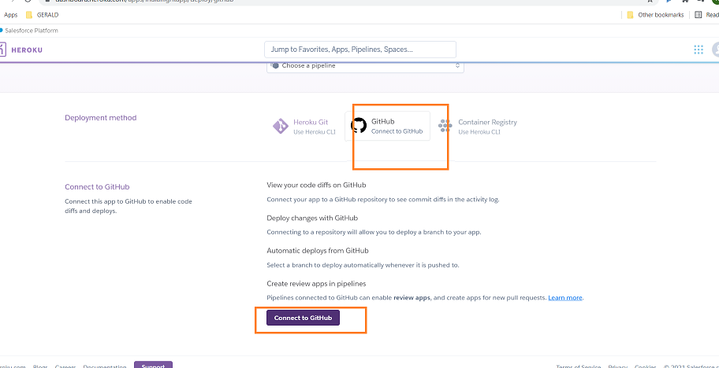

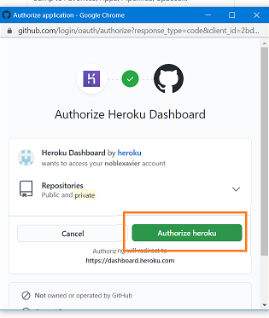

Search the Github Repository – flightdeployment

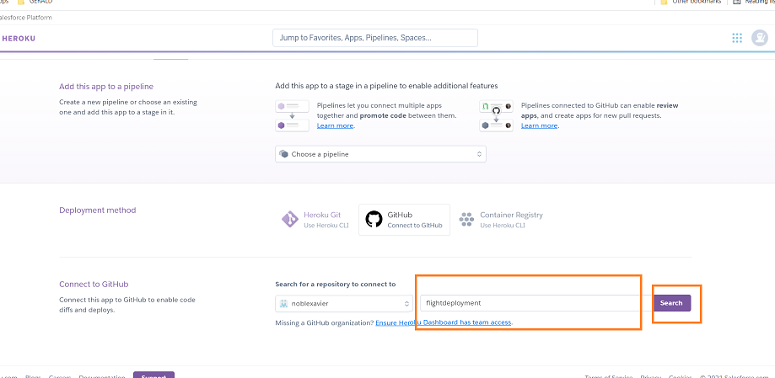

The Repository will be available in the below list

Select the repository and connect

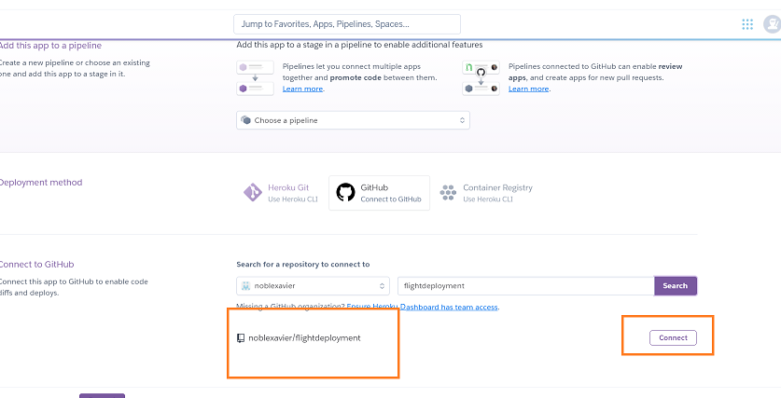

Enable automatic deployment

Any changes in the code in the git hub automatically deployed (Optional to select this).

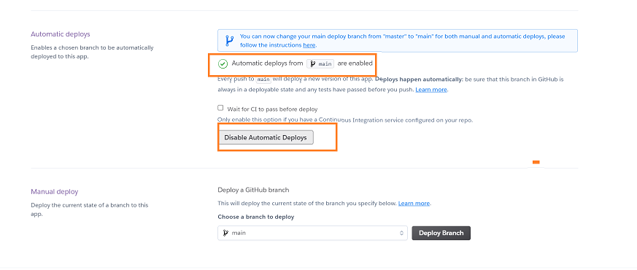

In the same screen under manual deployment

Click -> Deploy Branch

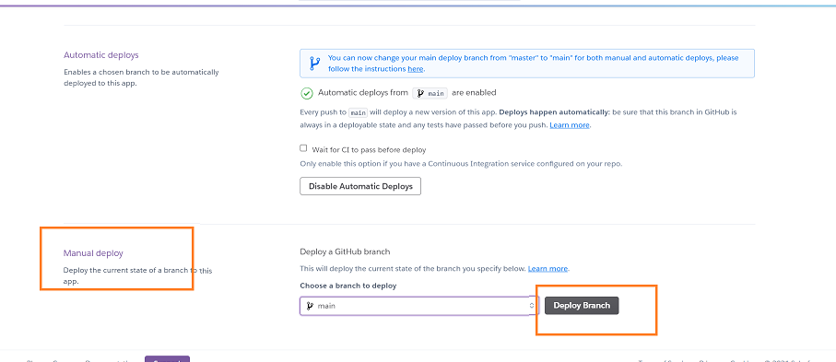

Scroll down the same screen, you can see the deployment details and deployment progress

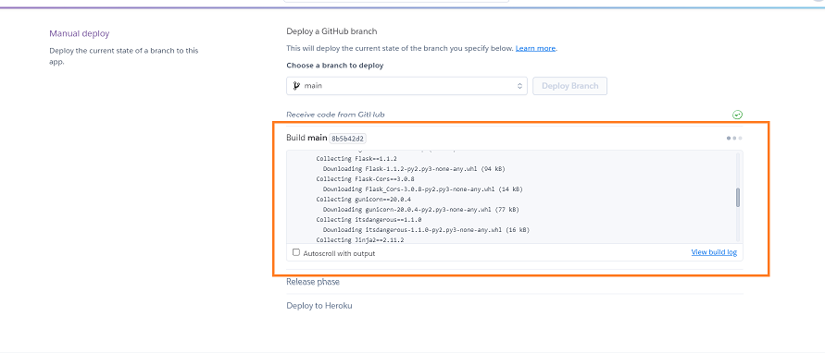

Once the deployment / Build complete Get the URL , then use the same in Browser.

<https://indiaflight.herokuapp.com/>

